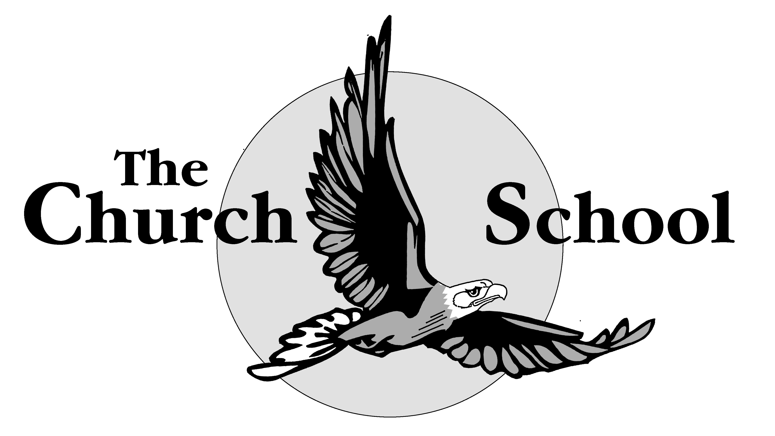
Baildon Church of England Primary School
and Nursery

COLLECTIVE WORSHIP POLICY

Mission Statement
In our school, we celebrate being part of God’s family. We inspire our children with a love of learning in a safe, happy environment, which will enable them to flourish and reach their individual potential.

Introduction
This policy outlines the purpose, nature and management of collective worship within our school and has the support of the school staff and the Governing body. The implementation of this policy is the responsibility of all teaching staff and reflects the school’s mission statement. This ethos reflects our status as a Church of England School.

Aims

The aims of the collective worship policy are to provide the opportunity for pupils to:
- worship God
- reflect on values that are of a broadly Christian nature and in their own beliefs
- develop a community spirit, a common ethos and shared values
- consider spiritual and moral issues
- respond to the worship offered
- reinforce positive attitudes
The school will fulfil its statutory duty in providing daily collective worship for all registered pupils (unless withdrawn by parents). This is usually provided within a daily act of worship (class, year based, key stage or whole school).

The Nature of Worship
Collective worship is the school community coming together to share in an act of Christian worship. It is concerned with reverence or veneration of God and pupils should be (at their level) capable of perceiving this. The main emphasis will be in the traditions of Christian belief and accord special status to the person of Jesus Christ. Within each term the majority of acts of worship will be of a broadly Christian character.

There are three fundamental principles underlying the provision of our acts of Collective Worship.
These principles are broadly outlined below:
1) Inclusive in nature;
2) Broadly educational in content;
3) Specifically Spiritual, Moral, Social and Cultural in content.

INCLUSIVE - this means that we want our acts of collective worship to:
- recognise and celebrate the diversity of cultures, life styles and religions which exist in our
multicultural society. However, the majority of the Acts of Collective Worship will be wholly or mainly of a broadly Christian character;
- have an atmosphere in which everyone feels valued and safe;
- be suitable for every child to attend unless withdrawn by his/her parents/guardians;
- focus on issues and experiences which are relevant to the children;
- include active participation by pupils, parents and members of the local community –

EDUCATIONAL - this means that we want our acts of collective worship to:
- reflect the aims of the School, and foster a sense of shared values;
- be valuable learning experiences and, as such, to be included in schemes of work and
curriculum planning;
- to enhance, complement and extend the curricular work;
- to provide an opportunity to celebrate the academic, social, personal or sporting achievements of the children;
- to provide an opportunity to learn how to behave in a large social gathering.

SPIRITUAL MORAL, SOCIAL AND CULTURAL - this means that we want our acts of collective worship to:
- provide a brief period of relaxation from the busy life of school, when children will have time to pause for thought in an atmosphere of peace and quiet. This involves a quiet and well-ordered arrival and departure;
- provide the children with an opportunity to contemplate the spiritual dimension of their life through music, images and words. The writings of the world's great religions, their prophets and followers provide a source of meaningful stories and philosophies for life;
- provide an opportunity for private quiet contemplation and prayers;
- have a sense of occasion that separates them from the rest of the school day.
- emphasise the value of prayer, meditation and silence
- promote thoughts about the needs of others.

Implementation
Frequency of Collective Worship
Acts of collective worship normally take place in the school hall or the gym and once a week within the classroom.
Our current arrangements for Collective Worship are:
Whole School Collective Worship on Monday and Tuesday
Whole school focus on hymn or songs of praise on Wednesday
Key Stage Collective Worship on Thursday
Class of Year Group Collective Worship on Fridays.

Character
Each experience of Collective Worship will be positive and will encourage a thoughtful response. The Christian ethos of the school will be explored and expressed by engaging with spiritual, moral, social and cultural issues.

Content
Themes for Collective Worship will be developed through a wide range of approaches to interest and challenge all of the children.
These may include story, poetry, art, artefacts, drama, science, music and song, ICT and links with other communities. The aim will be to make collective worship as interactive and inclusive as possible
Themes are identified for each half term which draw from the Liturgical Year, Festivals, Global Issues and Christian Values. In addition, visits and visitors are welcomed to school to lead Collective Worship. Themes are identified at the beginning of each half term and shared with staff.

Monitoring and Evaluation
A record of the content and character of the daily collective worship will be retained.
Views of pupils will be gathered to inform developments where appropriate in Collective Worship.
The policy will be promoted and implemented throughout the school and will be updated every year to reflect the organisation.
The policy will be reviewed in July 2017 to assess its effectiveness and implementation or earlier should it be required.

